BENY ESGUERRA
and New Tradition Music
NOMINATED FOR 2022 JUNO!!
Celebrating their JUNO Nomination for Global Music Album of the Year for Northside KUISi
w/ launch of three-part mini-documentary on the making of the album

Watch now on YouTube
Stream Here

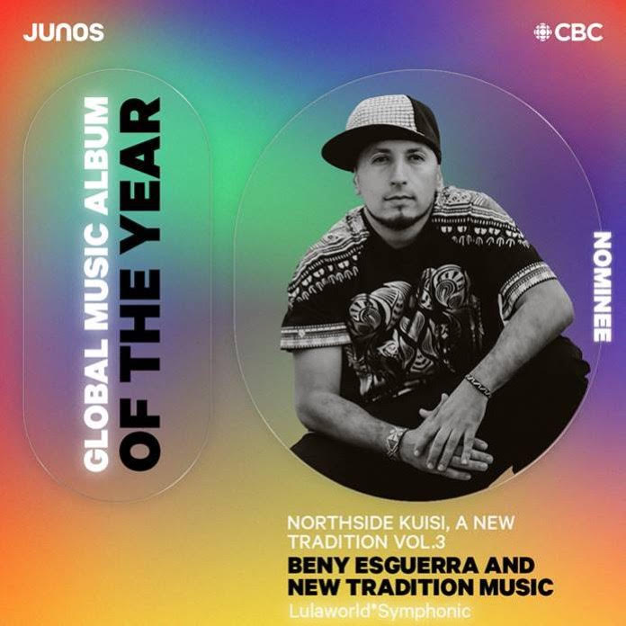 "This band won't fail to make you dance your ass off while immersing you in the richness of Afro-Indigenous Colombian heritage"
~ Exclaim! Magazine

TORONTO – BENY ESGUERRA and NEW TRADITION MUSIC’s current album Northside KUISi Vol 3 (Lulaworld Records) has been nominated for Global Music Album of the Year in the 2022 JUNO Awards, to be held in Toronto on May 15th. Esguerra and his band are celebrating their JUNO nomination with the launch of a three-part mini-documentary on the making of the album. For more information please visit any of the links below and the website.
On Northside KUISi Vol 3, Beny Esguerra and New Tradition Music incorporate hip-hop elements such as beatboxing, emceeing/spoken-word and turntablism with Colombian Afro-Indigenous música-de-gaita, champeta and modern cumbia. As with the previous two volumes, the current album delivers an urgent call for justice, environmental healing, and respect for ancestors and land treaties.

To mark the JUNO nomination, Esguerra launches a three-part documentary series on YouTube, plumbing the depths of the album, by delving into the concepts which it explores. Part 1 highlights the Afro Indigenous Roots, instrumentation, and the influence of hip-hop elements on the compositions; Part 2 examines the Condor and Eagle Prophecy, and how it has influenced the works, collaborations, and concept behind the album; and Part 3, in which Esguerra is joined by multi-instrumentalist, arranger, and producer Luis Orbegoso, as they dissect some of the compositional techniques used in arrangements and recordings.

Northside KUISi is a concept album narrated by news reporters from a distant future who speak an ancient, futuristic creole language made up of Lengua-Palenkera, Anishinaabemowin, Spanish, and English. It’s a carefully-woven song cycle of 12 songs with an extra seven hidden compositions that collectively chronicle the discoveries of an archeological dig, where traditional instruments from the Southern and Northern hemispheres are unearthed. The instruments found include a flute, a drum and a vinyl disc containing encrypted information from a prophetic time of transition for the world circa 2020 AD.

The album reflects Esguerra's experiences as a child who arrived with his political activist parents as refugees to Canada from Colombia. The compositions explore issues such as the mass exodus from South to North, environmental degradation, the celebration of instruments and traditions, global indignation to systemic racism and oppression, and the need for community collaboration and healing.

Inspired by the ancient prophecy of the Condor and the Eagle – which foretells the reunification of nations across the Northern and Southern hemispheres – Colombian-born, Mestizo, multi-instrumentalist and lyricist, Esguerra enlists artists from the North and South to collaborate on his works that also create bridges across diverse musical genres. Instruments included are the kuisi bunsi (Indigenous-Colombian flute), the hand drum (from Turtle Island), and the turntables (as used in hip-hop culture in the Bronx, NY).

Northside KUISi features an extensive list of Latinx, Mestizo, Black and Indigenous special guests including Silla, Artson, Mahlikah Awe:ri, Nimkii Osawamick, Zakisha Brown, Leang Manjarres Wong, DJ Grouch, DJ Classic Roots, Tracey Kayy, Raven Kanatakta, Steve Sanchez, Mat Stevens, Orlando 'Chato', DJ Chino, Jotaika Bops Atta, Mystro, Nathan Baya, Larry Blu, Louwop (Los Poetas), Mc McWatch, J Wize (Se7ens), Mamarudegyal, Hope, Che Uno and Rod Starz (Rebel Diaz).

With arrangements by producer Luis Orbegoso – who also provides, backing vocals, percussion and trombones – the album highlights core New Tradition Music group members Paul ‘Savilion’ De Francesco (beat making), Juan ‘Siez Swift’ Esguerra (turntables), Adam Solomon (electric guitar), Jonathan ‘Alacran’ Amador (electric bass) and Ernesto Espinoza (violin).

"Northside KUISi strives to create a dialogue between past, present and future while imagining a future where our descendants, languages and traditions thrive"
~ Beny Esguerra

Ruben 'Beny' Esguerra is also an arts educator, community worker and Ph.D. (ABD) candidate in Musicology/Ethnomusicology (specializing in traditional Colombian music and Hiphop culture). Recipient of the 2020 Ontario Arts Foundation’s Arts Educator Award, he is currently the music director of several community music education programs based in Toronto’s Jane-Finch neighbourhood. The album was created with support from the Toronto Arts Council and the Ontario Arts Council.

ARTIST LINKS:

Facebook | Instagram | YouTube | Spotify |

Lulaworld Records and Lula Music and Arts Centre at Lula Lounge gratefully acknowledge the generous support of The Toronto Arts Council, The Ontario Arts Council, The Trillium Foundation, Ontario Creates, Canada Council for the Arts, Canadian Heritage and FACTOR Canadian.

-30-

For more information, hi res photos, interviews, please contact:
MEDIA CONTACT:
Beverly Kreller, Publicist | SPEAK Music
bev@speak-music.com | 416-922-3620

